Use Case Realisation Report(Analysis) - Generate Separate Certificategenerate separate certificate
FOR
Volunteer Management System
(VMS)

CLIENT
PROJECT | Volunteer Management System (VMS) Volunteer Management System
TITLE | Use Case Realisation Report(Analysis) - Generate Separate Certificate
VERSION | 0.3a0.2a
DATE | 14-Aug-2011
 | ORIGINATOR
 | Name / Signature | Team 8S
 | APPROVAL
 | Name / Signature | Phung Kim Cuong, Dio
Institute of Systems Science |  | Document Reference
25 Heng Mui Keng Terrence  Singapore 119615 |  | VMS/T-1.4.1/1

 | Acceptance
 | Customer Signature |  | Customer Signature
 | Name & Designation |  | Name & Designation
 | Date & Company Stamp |  | Date & Company Stamp

Revision History

Date | Version | Description | Author
12-Jun-2011 | 0.1a | Creation | Team 8S
11-Aug-2011 | 0.2a | Update | Team 8S
14-Aug-2011 | 0.3a | Update | Team 8S
 |  | Refer to amendment history

Table of Contents

1. Brief Description 3
2. Flow of Events 3
2.1 Standard Flow 3
2.2 Exceptions 4
3. Interaction Diagrams 4
3.1 Domain Collaboration Diagram for Generate Separate Certificate 4
4. Participating Objects 5
4.1 Home Screen 5
4.2 MainController 5
4.3 GenerateCertificateScreen 5
4.4 Certificate Controller 5
4.5 OpenorSaveDialogbox 5
4.6 Project 5
4.7 Volunteer 5
5. Class Diagram 6
6. Derived Requirements 6
ANNEX D Amendment History 7

Use Case Realisation Report(Analysis) - Generate Seperate Certificate

Brief Description
The use case enables registered user with system administrator role to generate separate certificate requested by volunteer.

Flow of Events
The standard flow of events for this use case and any exceptions are described in the following subsections. See section 3.1for an overview of the participating Actors and Domain Objects.

Standard Flow

Precondition: System Administrator has logged in the system and use case 4.6 has been executed

This use case provides the user interface related functionality that will be provided to the User, as follows:
- The use case starts when the system administrator selects the Generate Certificate option from the HomeScreen user interface. The HomeScreen.getGenerateCertificateScreen() method is triggered.
- The HomeScreen.getGenerateCertificateScreen() triggers the MainController.show() operation which delegates to GenerateCertificateScreen.show().
- The show() launches the user interface GenerateCertificateScreen.
- The system administrator uses the GenerateCertificateScreen user interface to select or key in the certificate criteria like the volunteer name. When the system administrator clicks the Generate Certificate button in the form, GenerateCertificateScreen.enterCertificateCriteria() is called.
- The enterCertificateCriteria() will triggers the CertificateController.generateCertificate() to get the details information of volunteer and project that match the criteria.
- The CertificateController.generateCertificate() will triggers the Volunteer.getVolunteerDetails() operation to retrieve the details information of Volunteer and Project.getProjectDetails() operation to retrieve the details information of Project that match the criteria.
- After that, CertificateController triggers the OpenorSaveDialogbox.showCertificate() operation to get the certificate of requested volunteer.
- The system administrator use the OpenorSaveDialogbox user interface to choose save or open option to get the generated certificate.
- The OpenorSaveDialogbox.saveorOpen() operation will also triggers the OpenorSaveDialogbox.close() operation after system administrator choose the option and click OK button.
- The use case terminates after the system administrator gets the certificate.
.

Exceptions
- The following exceptions have been identified:There is no matching Certificate: if there is no matching Certificate for the selected project, the CertificateController will return empty data of Certificate and the GenerateCertificateScreen will show “No certificate found” message.

Interaction Diagrams

Domain Collaboration Diagram for Generate Separate Certificate
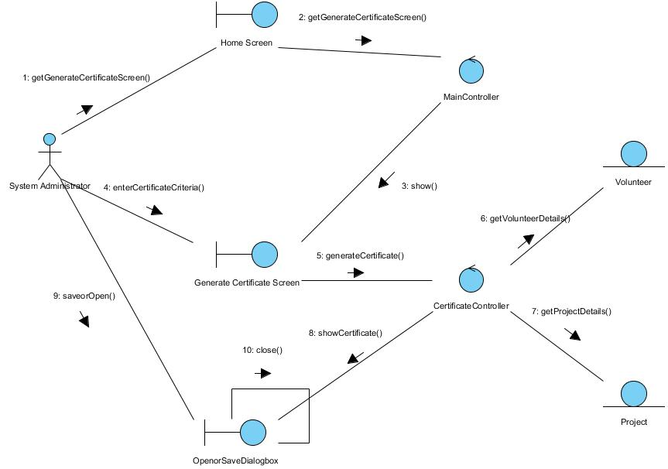

Figure 1 – Collaboration Diagram for Generate Separate Certificate

Participating Objects

HomeScreen
This boundary object is used to display the main menu of the system. The System Administrator actor uses this object to launch other user interfaces.

MainController
This control object coordinates the menu selection of the VMS system. It delegates the user requests to the specific use case control object for carrying out the use cases.

GenerateCertificateScreen
This boundary object is used to enter certificate criteria of requested volunteer by system administrator.

CertificateController
This control object coordinates the retrieving data of volunteer and project for certificate and generating certificate.

OpenorSaveDialogbox
This boundary object is used to save or open the generated certificate.

Project
This entity object stores all the project related details. This object represents information to be stored on a persistent basis.

Volunteer
This entity object stores all the volunteer details. This object represents information to be stored on a persistent basis.

Class Diagram

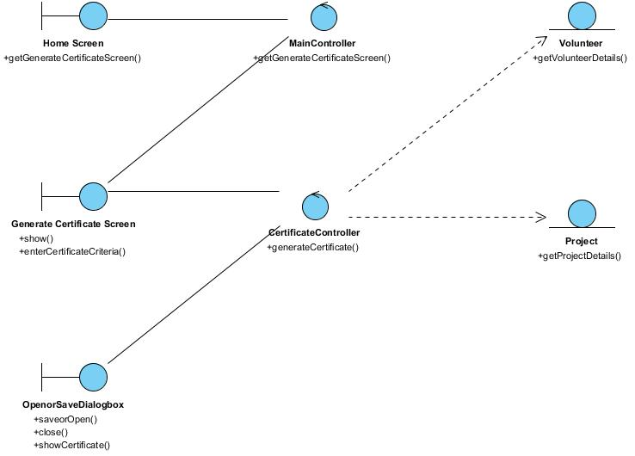
Figure 2 – Class Diagram

Derived Requirements
This system administrator’s PC keyboard or mouse will be used to select required criteria and view all the system responses.

ANNEX D Amendment History

This is a record of all amendments made to the Document.
Version | Chapter / Section | Page No | Notes of Amendments or Changes

